Lab Test-05
Use few-shot prompting to generate Python classes representing a Student and a Course with basic operations.
Hint: • Give ChatGPT 2–3 small class examples → Ask it to generate Student and Course classes. • Paste result to Colab to verify.
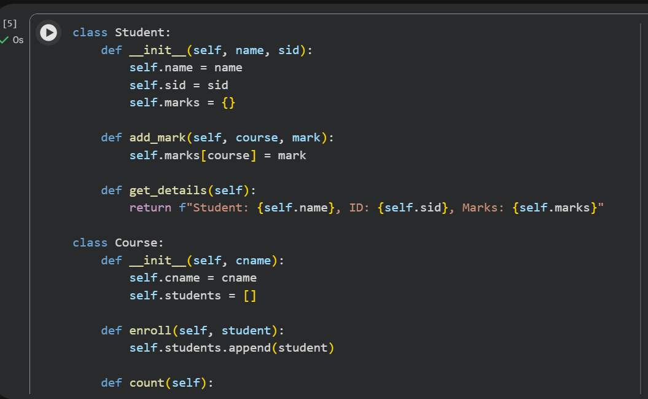
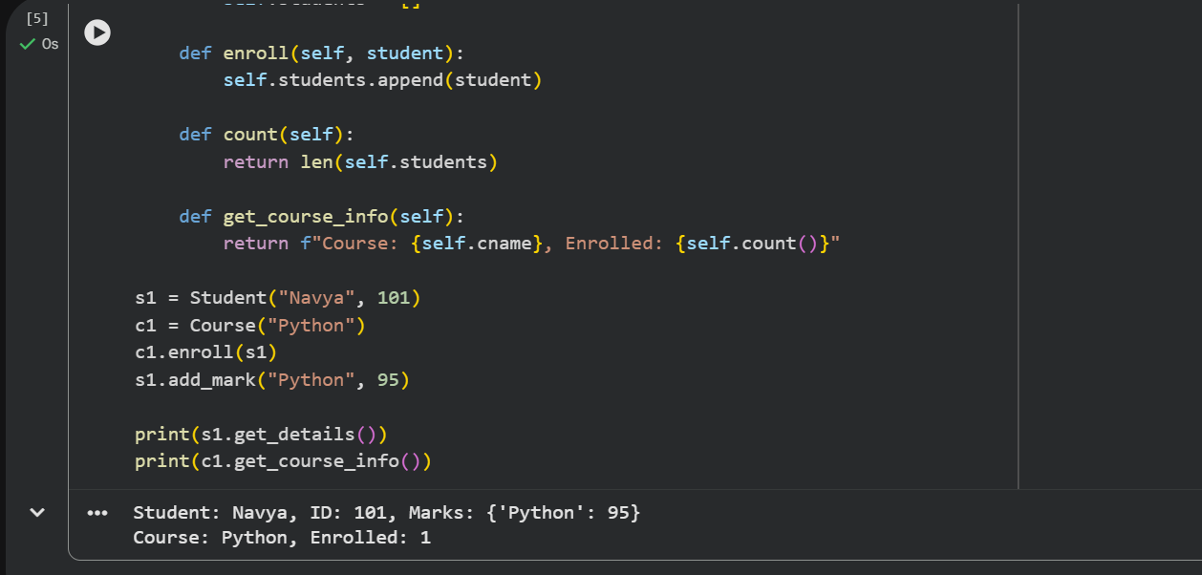
Explanation:
Few-shot prompting is a technique where we provide a model with a few small examples so it understands the pattern or structure we want.

Student Class
- Stores the student’s name, ID, and marks.
- Has a method add_mark() to add marks for a course.
- This makes the Student object store all information related to one student.

Course Class
- Stores the course name.
- Maintains a list of students who enrolled.
- Has a method enroll() to add a student to the course.
- Another method count() returns how many students are enrolled.

Use Copilot to automatically generate docstrings and comments for the classes, and verify clarity.
In VS Code, write """ above each method. • Copilot will auto-suggest docstrings → Accept/refine.
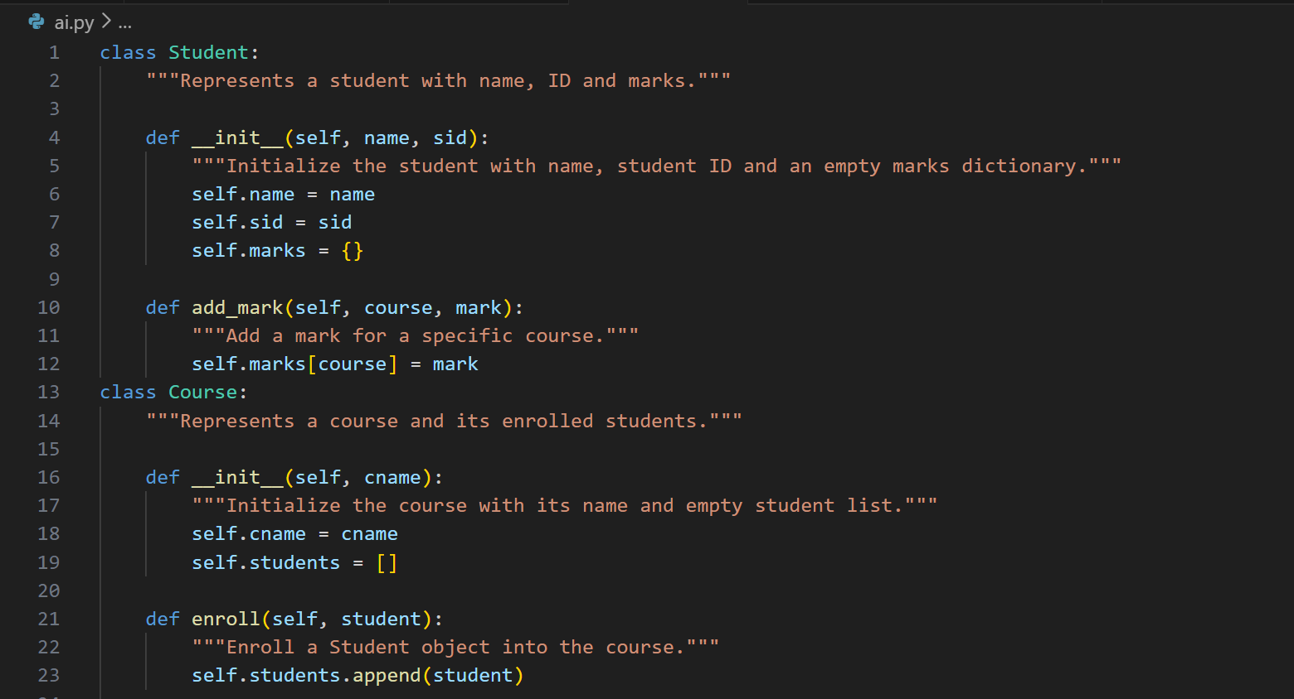
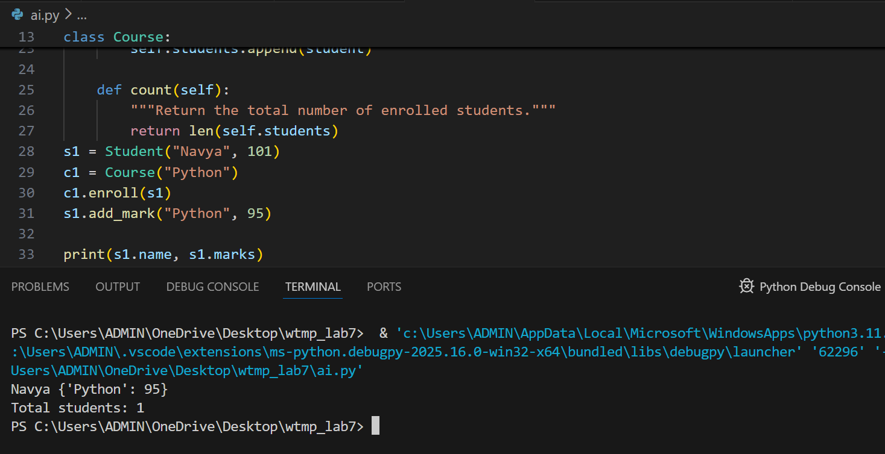

Explanation:
GitHub Copilot helps automatically generate meaningful docstrings.
By typing """ above a class or method, Copilot reads the code and suggests a suitable explanation.
These auto-generated docstrings describe what the class or method does, the parameters, and the return values.
After accepting or editing the suggestions, the code becomes clearer and more readable.

